Below are the step by screenshots of the two jobs that I created and the following updates in the tables of the landing dataset which was in the S3 bucket. I will not go through the detailed steps as it is already present in the document containing detailed lab steps, but just give an overview.

**Step 1:** Creating database “gluestudio”

**Step 2:** Creating the crawler “gluestudio_crawl”

**Step 3:** Crawler run successfully completed.

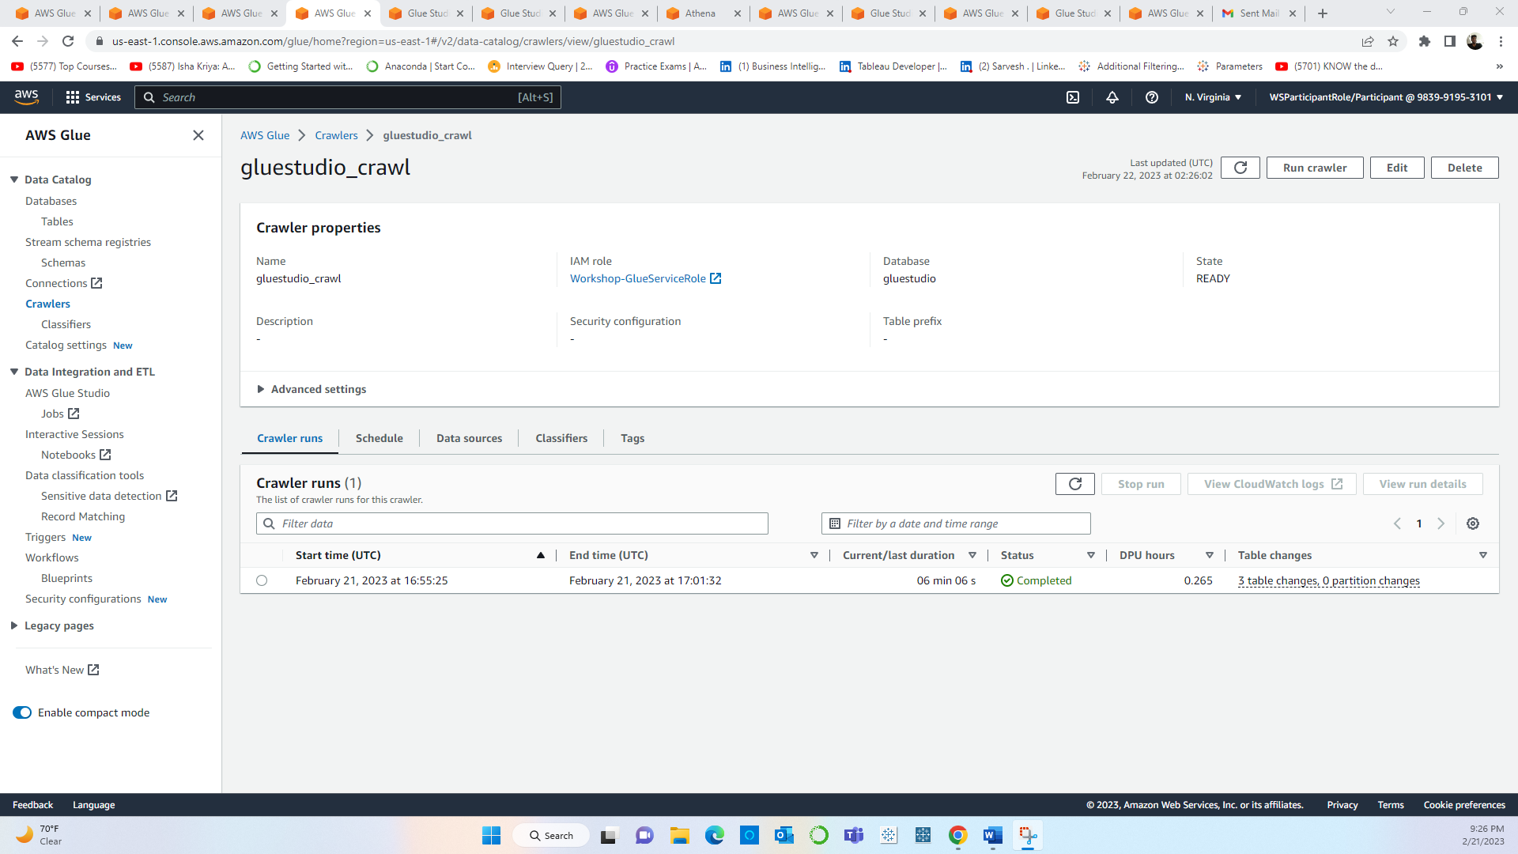

**Step 4:** After the crawler is executed successfully all the tables can now be seen in the technical Data Catalog of Glue

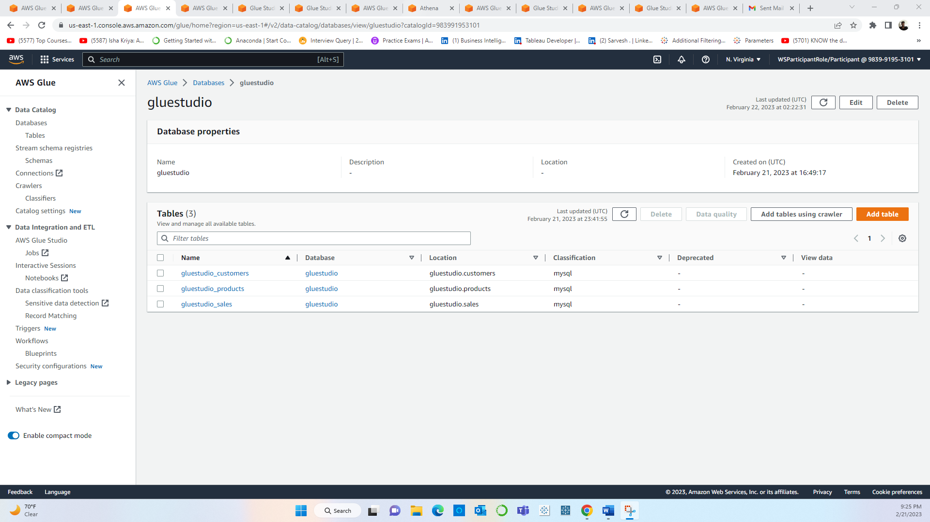

**Step 5:** Job 1 - Extract from a MySql DB and **transform** the data visually performing multiple actions of changing data types, selecting specific columns, joining tables, filtering data, and performing aggregations.

**Step 6**: Job 1 successfully Run.

**Step 7**: “sales-aggregation-report table” successfully created.

**Step 8:** Querying the table “sales-aggregation-report table” in **Athena** to verify if the data has been correctly populated.

**Step 9:** Creating the custom Regex pattern to mask date of birth.

**Step 10**: Creating the second ETL Job - Redact sensitive data from dataset using Glue built-in PII feature without writing code.

